

FACULTY OF SCIENCE & TECHNOLOGY

Department of Computing & Informatics

Forensic Computing & Security



**Tools & Technologies of Data Science February 6th 2020**

**Word Count: 2800**

**Paul-David Jarvis**

**s5115232@bournemouth.ac.uk**



New York Stock Exchange & Microsoft Corporation Stock

Big Data Analytics & Technologies Tools

**Table of Contents**

**Abstract** **4**

**Introduction** **4**

**1.0 Big Data Problem** **4**

1.1 New York Stock Exchange & Its Economic Relevance 4

1.2 5Vs 7

1.2.1 Volume 7

1.2.2 Velocity 7

1.2.3 Variety 7

1.2.4 Veracity 7

1.2.5 Value 8

1.3 Project Objectives 8

**2.0 Big Data Tools & Technologies Specification** **8**

**3.0 Big Data Tools and Technologies Implementation** **9**

**4.0 Results and Discussions** **10**

**5.0 Conclusions and Future Work** **16**

**6.0 References** **16**

# 

**Table of Figures**

Figure 1: Microsoft Corporation Stock Price Chart. - (Macrotrends.net, 2020)............................................ **5**

Figure 2: Microsoft Corporation Annual Stock Data. - (Macrotrends.net, 2020).......................................... **6**

Figure 3: Code Dependencies & Libraries................................................................................................... **9**

Figure 4: Support Vector Regression & Linear Regression Models........................................................... **10**

Figure 5: February 24th Stock Record....................................................................................................... **10**

Figure 6: February 24th Stock Open Price Prediction................................................................................ **11**

Figure 7: Microsoft Corporation’s Stock Moving Average.......................................................................... **12**

Figure 8: Microsoft Corporation Candle Stick Graph - (MSFT - candlestick chart analysis of Microsoft Corporation, 2001)..................................................................................................................................... **12**

Figure 9: Microsoft Corporation’s Stock Opening Price from 06/02 to 21/02............................................. **13**

Figure 10: Microsoft Corporation’s Stock Opening Price for 11/02 Prediction........................................... **13**

Figure 11: Microsoft Corporation’s Stock Opening Price for 20/02 Prediction........................................... **14**

Figure 12: Microsoft Corporation’s Stock Opening Price for 21/02 Prediction........................................... **14**

Figure 13: Microsoft Corporation’s Stock predicting for the 27th............................................................… **15**

Figure 14: Microsoft Corporation’s Stock Opening Price for 27/02 on Yahoo........................................… **15**

Figure 15: Microsoft Corporation’s Stock Opening Price for 27/01........................................................… **15**

# Abstract

I have decided that my big data problem is how I could use big data and big data sets such as historical financial stock data sourced from Kaggle that was sourced from the New York Stock Exchange (NYSE) and how I can use data analytics like Python and Machine Learning algorithms (MLA) like Support Vector Regression (SVR) and Linear Regression (LR) models to predict Microsoft Corporation’s (MSFT) stocks. In this project, I will be researching into the NYSE and MSFT as well several different modules in Python like Pandas, Matplotlib, Scikit-Learn and others that I could use to analyse the information in the data set and predict future and unknown stock prices. This project and other similar projects are important within the financial section and especially within the world of trading as in the 21st century most jobs within the NYSE now are investment analysts looking, learning and designing algorithms that can be used to make stock trades.

# Introduction

There are four paradigms of science: Empirical Evidence, Theories, Computational, Data Intensive. The first paradigm of science is empirical evidence is information gathered by the means senses. This information is gathered particularly by observing and documenting potential patterns and behaviour of a certain experiment. The second paradigm of science is theories. This is an explanation of specific requirements such as measurement and observation of an experiment that can be repeatedly tested and verified. A theory could be ultimately rejected if new scientific evidence is gathered and can’t be explained. Computational is the third paradigm of science. It is often referred to as “scientific computing”. This paradigm uses advanced computing power and its capability to solve complex problems found in nature. The information gathered is understood through the analysis and mathematical modelling, extremely different from empirical and theories. Data intensive is the fourth paradigm of science. The idea of this paradigm was first conceived during the 90s due to the internet and the volume and velocity of data that is being generated and needing processing, analysing and sharing.

# 1.0 Big Data Problem

## 1.1 New York Stock Exchange & Its Economic Relevance

The NYSE is open from Monday to Friday and is only closed on the weekends and certain NYSE’s holidays. The NYSEproduces roughly 2 terabytes every day so we can calculate that it produces roughly 500 terabytes or half a petabyteevery year. Due to the volume and velocity of the data that the NYSE is producing there will be certain technical issues that will arise.

Microsoft was founded in 1975 and went public just over a decade later in 1986 at $21 per share and now in 2020 they are $100 plus, this can be seen in figure 1. Because MSFT is only one in thousands of other companies listed on the NYSE means that the volume of data for MSFT is not necessarily big data but has the potential to grow due to the velocity of the data.

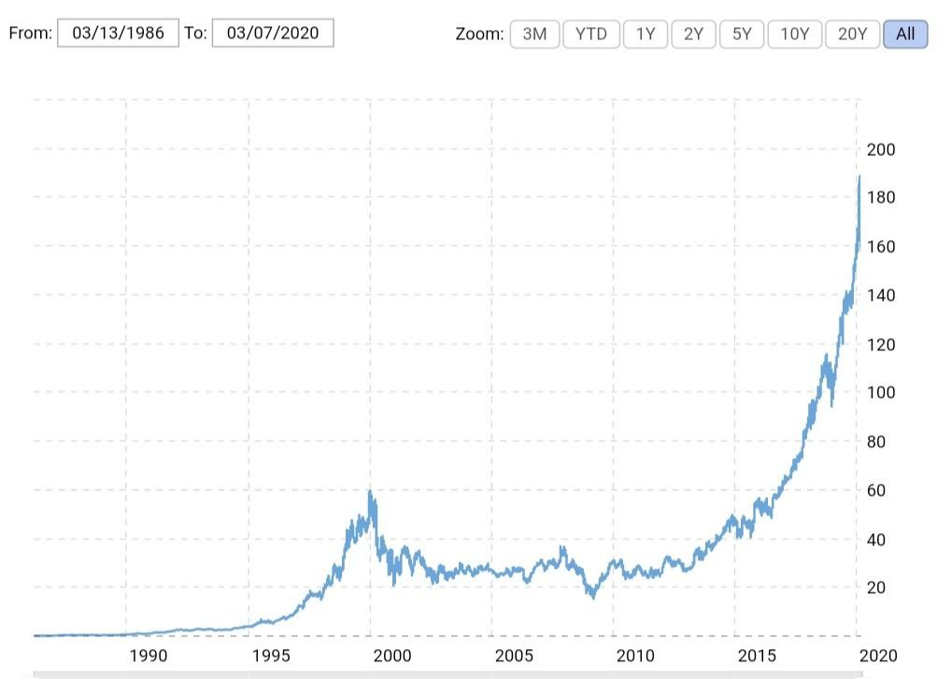

Figure 1: Microsoft Corporation Stock Price Chart. - (Macrotrends.net, 2020)

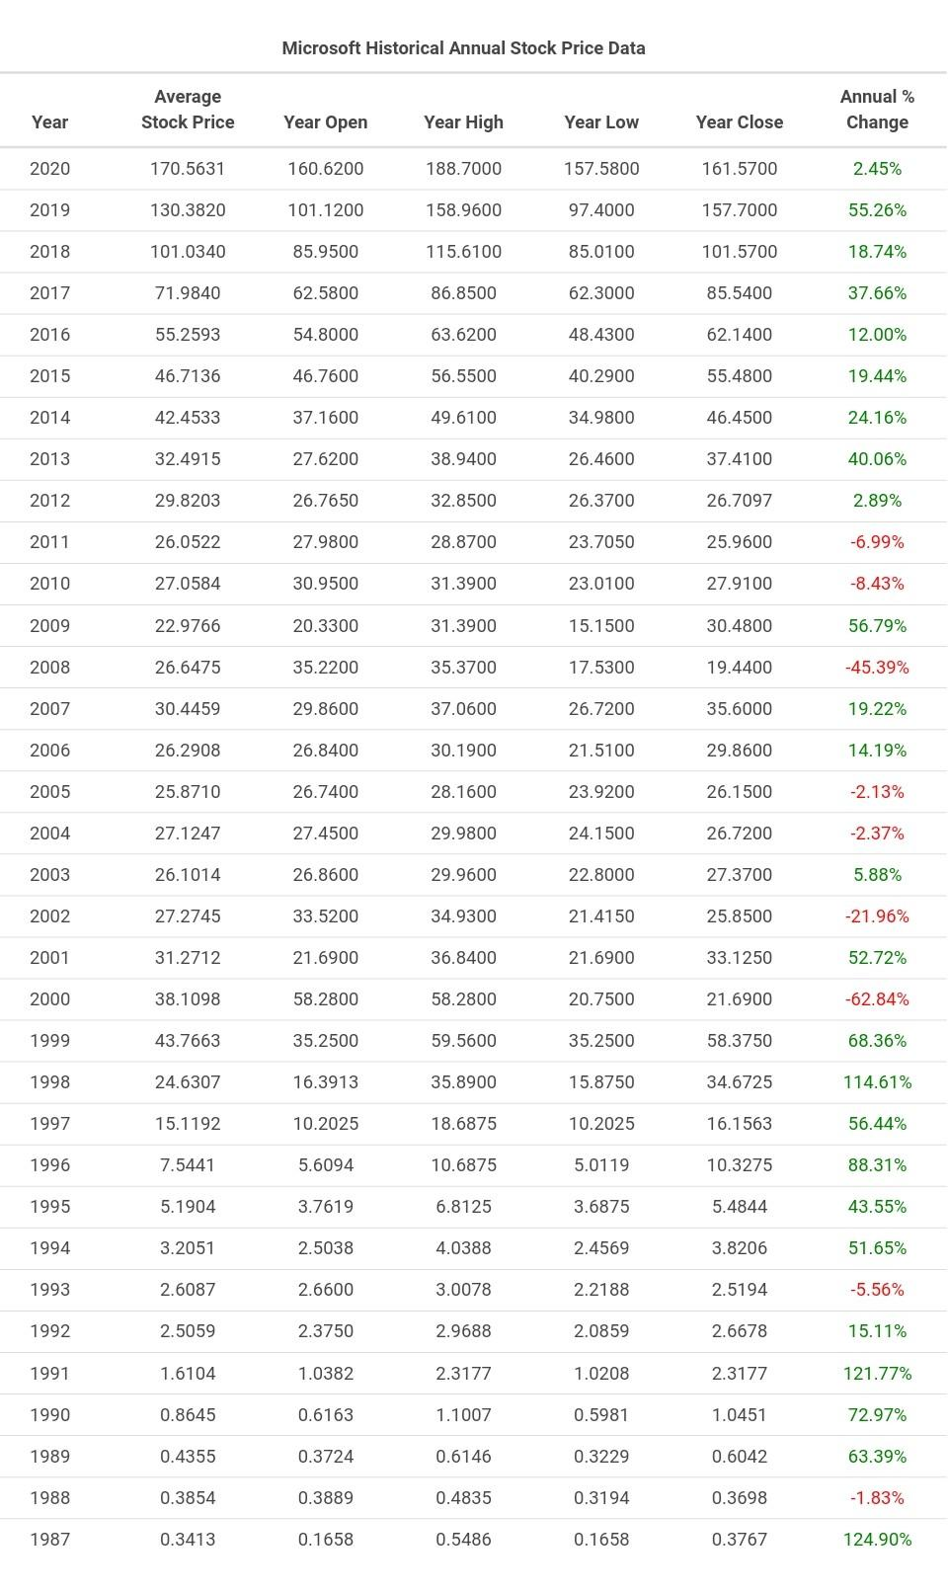

Figure 2: Microsoft Corporation Annual Stock Data. - (Macrotrends.net, 2020)

## 1.2 5Vs

### 1.2.1 Volume

The NYSE produces roughly 2 terabytes a day at the end of the closing bell and 500 terabytes roughly a year, this volume of data will introduce technical challenges when it comes to storing the processing the data. MSFT’s historical financial data set that I am using which was sourced from Kaggle isn't necessarily big data or a big data set but has the potential to grow every day.

### 1.2.2 Velocity

The NYSE produces data every weekday at the end of the day. The stock exchange is closed on weekends and certain holidays so it's opened roughly 260 days a year. The velocity of my data set that I am using is that it grows depending on the type of data set of MSFT stock. For example, If you use daily data then the velocity is that it’s growing daily or if you use annual historical data then it grows every year, you can also import real time data from the NYSE with tickers that is every millisecond.

### 1.2.3 Variety

The historical data set that I am using off Kaggle that was sourced from the NYSE’s data variety is unstructured and is a TXT file. I can easily convert them into semi structured CSV files that made it much easier to use Pandas library in Python and it’s method read_csv. This was also efficient as the primary dataset being the full over 200 records CSV file was less efficient than using the second dataset I created which is the historical MSFT’s stock data but cut down to roughly 20 records. The data set I am using has 7 columns: Date, Open, High, Low, Close, Adj Close and Volume.

### 1.2.4 Veracity

The data that the NYSE produces is extremely trustworthy. Plenty of Financial companies share their data with the NYSE and the SEC The data that I used was sourced from Kaggle which was sourced from the NYSE and the NASDAQ stock market and therefore making it trustworthy. However, it should be noted that the stock market could be possibly manipulated by artificially inflating or deflating the price of the stocks for personal gain, there are a few ways to manipulate the price of the stock but one way is for a company to place hundreds of small orders at a low price in an attempt to give the impression to anyone looking at this specific stock that there is something wrong.

### 1.2.5 Value

The data is extremely valuable as the data that is produced by NYSE is used to provide valuable information to traders so they can be informed with all the facts when it comes to making their trades. The data set that I am using to predict MSFT’s stock differs in its value, it's historic data collected over several years so at first it might be discarded as unuseful due to it being outdated, however, I used this historicaldata to analyse it and I was able to plot the data on charts and discover future trends that were extremely on point.

## 1.3 Project Objectives

The main objective of this project is to analyse MSFT’s stocks to identify trends that can be used to predict future stock. I first downloaded the historical MSFT stock from a trustworthy source like Kaggle and then converted the downloaded unstructured MSFT TXT file into a semi structured CSV file. We import the downloaded historical MSFT’s stock CSV file into Python and then use the necessary libraries such as Pandas, Numpy and Sklearn to create MLA and SVR and LR to analyse the stock and Matplotlib to visualise and plot the data produced graphs and charts and finally document our results and discuss the results regarding if I achieved these objectives and to discuss any future work with the prime objective to make this project more efficient using other big data technology.

# 2.0 Big Data Tools & Technologies Specification

I have identified several tools and technologies I could use in order to solve my big data problem. For example, I could use Hadoop that can be used by loading the big data and data sets onto servers or machines that are running Hadoop software and the large data sets are then split into pieces and spread across the Hadoop software running servers. I then send the code to each server and the results are returned whole, this being MapReduce. This addresses efficient storage and efficient processing of the big datasets we use when they grow in volume, velocity and variety.

I could also use Python 3 and some of Python modules like Scikit-Learn and Matplotlib to develop scripts that include MLA which will allow me to efficiently address the processing of the data as Scikit-Learn will allow me to generate SVR and LR models that will allow me to read and import the data into the algorithms and process it effectively to get the results needed, I can also use Python’s modules like Matplotlib as well to visualise my data that the SVR and LR models generatedand theresults to identify trends that can be used to predict future and unknown price that would solve my proposed big data problem.

I could also use AWS and their wide range of big data and analytic services such as Amazon Redshift which is an analytic tool and data warehousing. Amazon Redshift is a fully managed petabyte-scale cloud-based data warehouse designed to store and analyse big data and big data sets. Amazon Redshift delivers fast performance for querying data due to its column-oriented database. Each Amazon Redshift data warehouse contains a collection of nodes which are computing resources put together to form a cluster. Each one of these clusters runs its own Amazon Redshift engine and contains databases filled with clients data sets. It solves the technical issue that occurs regarding the volume and velocity of data due to its fast processing and scalability with the ability to buy more clusters of data.

# 3.0 Big Data Tools and Technologies Implementation

I used Python 3 and Google Colab to develop the scripts needed in order to solve my big data problem. I used the Pandas method read_csv to read the MSFT historical stock data and create a data frame that I can use to call the data. I used Scikit-Learn to import MLA SVR and LR Model, using Sklearn, I created 3 SVR Models: Radial Basis Function (RBF), Polynomial (Poly) and Linear (Lin) and trained them by fitting it with dates and prices, in addition to this, I also used Sklearn to create and train a LR model. I then used Matplotlib to plot the results from the data returned from the 3 SVR models and 1 LR model as well as MSFT stock data to see which model fits the MSFT stock data best.

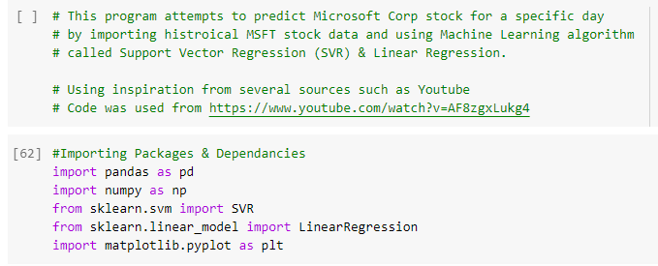

Figure 3: Code Dependencies & Libraries.

Figure 4 is a screenshot of the python code that was used to generate the 3 SVR models: Linear, Polynomial and Radial Basis Function and the LR model. This also shows the code that is used to train the SVR and LR models by feeding them the dates and prices arrays. You can also see within the screenshot, the code that is used to create the chart and graphs that includes all the information and data that the SVR and LR models returns as well as the scatter data used to plot the MSFT’s opening stock price using Matplotlib.

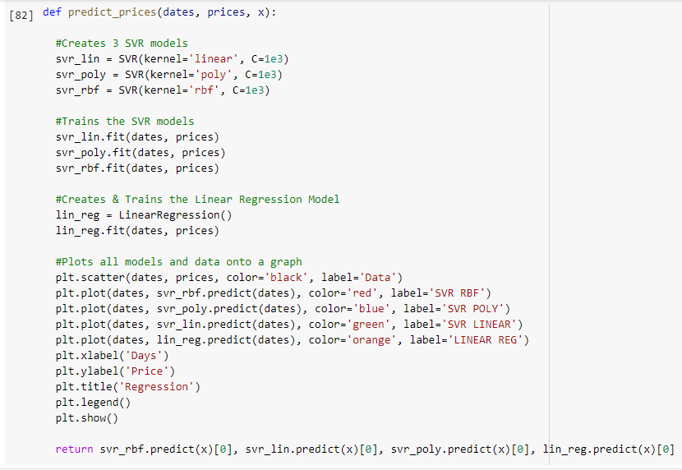

Figure 4: Support Vector Regression & Linear Regression Models.

# 4.0 Results and Discussions

My original MSFT stock dataset that I used which was sourced from Kaggle had roughly 200 records of historical stock prices and in developing the project further I discovered that I needed to reduce and cut it down to roughly 20 records, this doesn't change anything or reduce the likeliness of success for this project as the 20 records were enough data to predict an unknown future price.

Figure 5 shows a screenshot of the code that prints the last record and the record itself for the 24th of February 2020 that is stored in the MSFT historical stock price CSV file. I will be using this last record so I can test and confirm instantly whether or not the SVR and LR models have successfully predicted a float number close enough to the open price shown in figure 5.

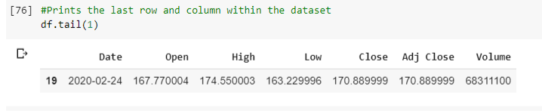

Figure 5: February 24th Stock Record.

Figure 6 is a Regression chart that was produced by the three SVR and LR models that I created and trained. The array number ([[“24”]]) is for the date which is the last record in the reduced data set shown in figure 5, this is one of the reasons why I predicted the opening stock price for the 24th of February because it allowed me to easily check whether or not the all four models predicted a float number anywhere near the actual opening price. The best SVR model that aligns with the scatter data that shows the MSFT stock opening prices is the RBF and the first float number (“169.62725480769492”) is the predicted price for the 24th of February 2020 which was $169 and was extremely close to the opening price that you can see in figure 5 and was $167 or 167.770004 for that date. My SVR RBF model prediction was only $2 or 1.09% (1.09490117599%) off.

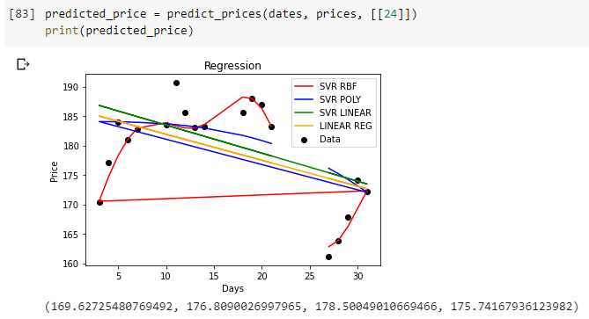

Figure 6: February 24th Stock Open Price Prediction.

In conclusion, regarding my objectives, I successfully completed my primary objective by using Python’s Scikit-Learn module and SVR and LR models to predict MSFT’s 24th of February 2020 opening stock price with an error of $2. In addition to this, I was also able to complete my other objectives by using Matplotlib to virtualise all my information and data on graphs like the Regression chart that includes the SVR, LR models and MSFT’s opening priceslike the one in figure 6. I was also able to produce another chart likefigure 7 which is a chart of MSFT’s stock moving average which can be used to identify the direction of the trend and also determine risks, this is done by smoothing out the price and filter out anomaly fluctuations caused by random short term price. I also and looked into producing a candlestick graph for Microsoft Corp’s stock but Matplotlib.finance was removed and was the module I needed that would allow me to produce the candlestick chart as seen in figure 8 that was sourced from online and has the same data plotted on it.

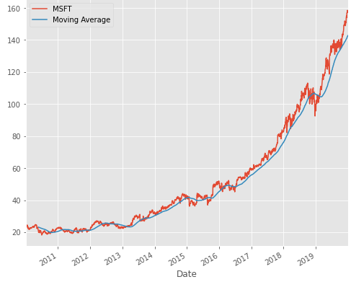

Figure 7: Microsoft Corporation’s Stock Moving Average.

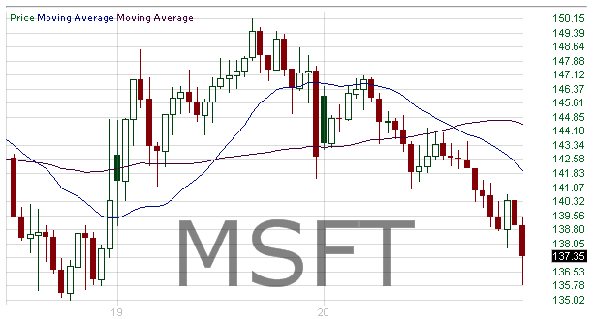

Figure 8: Microsoft Corporation Candle Stick Graph - (MSFT - candlestick chart analysis of Microsoft Corporation, 2001)

I wanted to reinforce the success of my primary objectives by performing several more tests and attempting to predict more than a single opening price for MSFT. When looking over MSFT’s historical stock prices, I saw that on the 11th of February there was a sudden rise in the opening stock price by roughly $5 to $10, this can be seen in figure 9. I wanted to know which SVR model or the LR model would predict closest to the anomaly opening stock. The SVR RBF model was $7 off and can be seen in figure 10. Taking into consideration that the models are trained by using this data, it makes sense that RBF returned a prediction that alligns more with the previous prices.

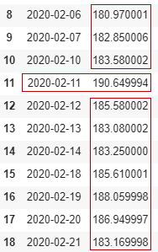

Figure 9: Microsoft Corporation’s Stock Opening Price from 06/02 to 21/02

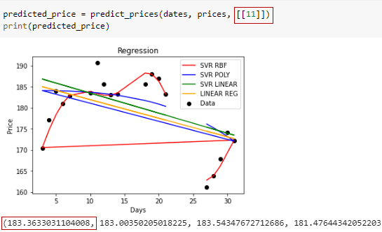

Figure 10: Microsoft Corporation’s Stock Opening Price for 11/02 Prediction

In addition to predicting the opening stock price for the 11th of January or February. I also threw the prediction models on the 20th and 21st of FebruaryThe SVR RBF model predicted both of these dates opening stock price to near almost exact regarding the price rounded up to no decimal places. These results can be seen in figure 11 and figure 12.

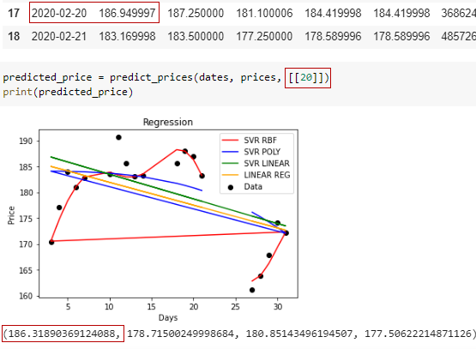

Figure 11: Microsoft Corporation’s Stock Opening Price for 20/02 Prediction

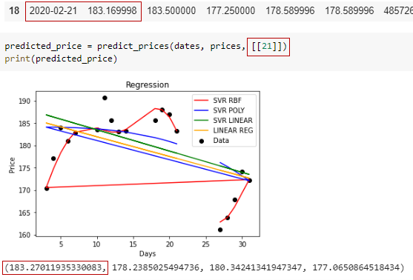

Figure 12: Microsoft Corporation’s Stock Opening Price for 21/02 Prediction

I also wanted to see what would happen when I tried to predict using the MLA models MSFT’s opening price with the same day. I ran the MLA models on the 27th. I wanted to try and predict the opening stock price for the 27th of February which is a date that wasn’t in my revised MSFT’s historical stock price data set. The SVR RBF model returned $162 that can be seen in figure 13. The opening stock price for the 27th of February according to Yahoo finance was $163 and this is shown in figure 14 . I also noticed the opening stock price for the 27th of January was $161 that can be seen in figure 15. I am not certain what month the model predicted.

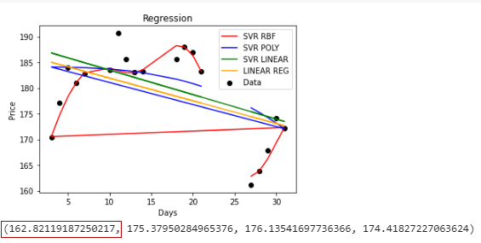

Figure 13: Microsoft Corporation’s Stock predicting for the 27th

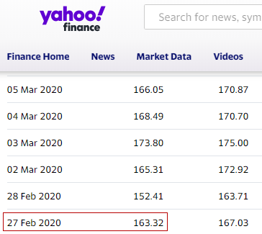

Figure 14: Microsoft Corporation’s Stock Opening Price for 27/02 on Yahoo



Figure 15: Microsoft Corporation’s Stock Opening Price for 27/01

# 5.0 Conclusions and Future Work

I enjoyed this project overall. It was rocky at the start but I found tons of great resources that helped a lot from youtube and official python documents and official python module documents. I enjoyed reading and learning about how the NYSE actually works and was interested in looking into an essential company like Microsoft. I learnt a lot about the libraries that I used like Matplotlib but more importantly, Scikit-Learn and the MLA SVR and LR. I was also happy to achieve the objectives I set out when first researching and beginning this project, those being able to predict future and unknown stock as well as plotting the data on charts produced by Matplotlib.

One of my future objectives of this project and something that I think would be incredible to achieve would be changing the way the ML SVR and LR models are coded and trained in order to predict more specific dates. One of my tests was to throw the MLA a date that is used more than once like the specific day such as the 27th. I think it would be amazing to be able to use the specific day, month and year to predict the opening stock price as this would be more efficient and would solve my problem shown in figure 13, figure 14 and figure 15 as I am unsure whether the MLA model predicted the 27th of January or February.

In regards to future work, It was interesting to see how we could possibly use the NYSE and big data sets in order to make this entire process more efficient with big data tools like Hadoop, AWS or Azure. When researching how to make this process more efficient using industry tools like Hadoop and AWS, we could potentially do some incredible things like predict future stock every day for a specific company or even maybe we could potentially feed all stock data from the NYSE or NASDAQ stock market and predict the stock for multiple companies everyday.

# 6.0 References

Macrotrends.net. (2020). Microsoft - 34 Year Stock Price History | MSFT. [online] Available at: https://www.macrotrends.net/stocks/charts/MSFT/microsoft/stock-price-history [Accessed 8 Mar. 2020].

Hotcandlestick.com. 2001. *MSFT - Candlestick Chart Analysis Of Microsoft Corporation*. [online] Available at: <https://www.hotcandlestick.com/MSFT> [Accessed 22 March 2020].

*Computer Science*. 2019. [video] https://www.youtube.com/watch?v=AF8zgxLukg4&t=693s.